WHISKEY FLAT DAYS

February 16-19 2024

Craft/Commercial Vendor Application
REGISTRATION DEADLINE DECEMBER 30, 2023
Date ____________________

Business Name Email:
Please print Please print clearly

Address
Mailing address City Zip

Contact Person Phone ( )

Driver’s License # and State Birth date

Items Being Sold

Booth spaces are 10’x10, place X in which type you are applying for, then number of spaces, then line total
CHAMBER MEMBER $220 | NON-MEMBER $275 | Quantity of spaces______ | $
$50.00 per 15-amp single circuit. If you require more amps, then you will need to purchase additional circuits. Electricity where available is extremely limited. |  | Quantity of circuits_____ | $
$50 (PER SPACE) penalty if you do not have “Additionally Insured Certificate” (see details line 1 vendor agreement) |  |  | $
MANDATORY $100 deposit (no exceptions). Please see attached CANCELLATION & REFUND POLICY |  |  | $100
LATE FEE - $50 (PER SPACE) After Registration Deadline DECEMBER 30, 2022 |  |  | $
Grand Total Enclosed

2023 Whiskey Flat Day Vendor Yes____ No____

Please be prompt! All spaces are on a First come – First served basis
:
COMPLETE APPLICATION PACKET MUST INCLUDE ALL THE FOLLOWING:
- Payment in full (note: NO personal or business checks accepted)
- VALID INSURANCE CERTIFICATE (see #2 vendor agreement)
- PHOTOS/LIST of ALL items being presented for sale.
- Complete Board of Equalization Form 410-D (enclosed) REQUIRED
- Please return the entire 6 page packet signed, initialed & dated by the deadline date listed above.

Absolutely No Personal Checks Accepted

Debit or Credit Cards Accepted (Please use the Credit Card Authorization Form)

Make Money Orders or Cashier’s Checks Payable To: Kernville Chamber of Commerce
P O Box 397
Kernville CA 93238

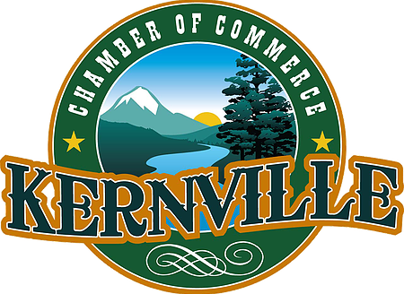

Vendor Selection Policy

  - The Kernville Chamber of Commerce Board of Directors approves all vendors in this order:
    - Chamber Member
    - First Right of Refusal
    - Non-Member Year-Round Local Vendor (Kern River Valley)
    - Outside Vendor (based outside of Kern River Valley)

  - Kernville Chamber of Commerce Members will have top priority in placement at all spaces, including Food Booths and Craft/Commercial locations.

  - First Right of Refusal. If a vendor attended the previous year and wants to return, they have the right to do so providing they turn in their application before the deadline and are a Chamber member. First right of refusal is voided if the vendor is NOT a Chamber member, and an incoming vendor is a Chamber member.

  - Year-Round Local Vendors have priority over outside vendors if the above two criteria (bullet 2 and 3) are not met.

  - We reserve the right to limit the number of vendors selling similar items or services. This number will be determined by the Board of Directors based on each event and the type of service.

  - In cases of duplication, priority goes in the order listed under bullet 1 above.

  - Completed Registration consists of the following: completed vendor application, signed Vendor Agreement, Insurance Certificate, proof of valid seller’s permit and payment in full.

  - Completed Registration must be received by the due date.

  - Registration completed after the deadline will be accepted ONLY IF space is still available and the products offered enhance the overall vendor mix. A $50 late fee will also be assessed.

  - Vendors that have turned in completed registration forms and payment will be notified of acceptance at least 6 weeks prior to the event.

  - The Kernville Chamber of Commerce reserves the right to reject a vendor with a majority vote if the decision is made that there is reasonable cause for the vendor not to attend.

Vendor Selection Policy: I have read and understand all the above and agree to this policy.

Print Name *Signature and Title Date
WHISKEY FLAT DAYS™ HOSTED BY THE KERNVILLE CHAMBER OF COMMERCE
February 16-19, 2024
REGISTRATION DEADLINE DECEMBER 30, 2023
Vendor Agreement
Read and initial each section.

_____PAYMENT IN FULL must accompany your application along with your Certificate of Insurance. Your space will not be confirmed until all monies are received, a valid seller’s permit is confirmed, and insurance requirement is in order.

_____Certificate of Insurance stating: The “Kernville Chamber of Commerce, its Officers, Directors, Employees, and Agents are Additional Insured”. Liability must be a minimum of $1 Million. Without a Certificate of Insurance your FEE will be $50.00 per space. This FEE is not insurance, it is a penalty.

_____Photos MUST accompany application, even if you have been here in the past, showing all items you will be selling. Any inappropriate items will be asked to remove them. All items for sale are subject to approval before the event. All booths will be closely monitored for quality and rule compliance.

_____Booth locations are assigned on a first come first serve basis. We will do our best to honor all requests. However, a request does not guarantee booth location. See attached “Vendor Selection Policy”.

_____ MANDATORY CHECK-IN. You must check-in prior to setup. Vendors will receive a vendor badge indicating their space number. Check-in will be at the chamber office which is located at 11447 Kernville Rd. in Kernville.
Check-in hours are as follows: Thursday 02/15/24 9a.m.-4p.m. Friday 02/16/24 7a.m.-10a.m.
Vendors have the option of setting up Thursday after 5p.m, however all booths must be completely set up by NOON on Friday. Badges must be displayed on your booth the entire weekend and must be returned to the chamber information booth or chamber office upon check-out.

_____You MUST stay within your own allotted space, as indicated on your space badge. Space size is 10x10. NO SPRAWLING, NO EXCEPTIONS. We are monitoring this closely. Violators will forfeit their deposit and banned from future events.

_____Spaces are to be occupied and remain open Friday 12p.m.- dusk and Saturday & Sunday 9am -6pm. Monday is optional 9a.m.-1p.m. If you need a break, please contact event staff. Any Booth packed up before 6PM on Sunday WILL forfeit their $100 deposit & considered last in line in filling spaces in future events.

_____Please keep your area clear of trash, debris, etc. Trash receptacles will be available near the sites. Vendors may NOT deposit cooking grease or oils in trash cans or dumpsters. If depositing large boxes, please make sure they have been flattened. You will forfeit your $100 deposit if your booth space is left with trash. NO exceptions. Please notify event staff, if you are unable to remove all booth supplies in a single trip. This will help assure remaining items are not deposed of.

____Flags or banners that will obstruct the view of other spaces may not be put up.

_____ANY MERCHANDISE INCLUDING, BUT NOT LIMITED TO, BASEBALL CAPS, WESTERN HATS OR SHIRTS OF ANY KIND WITH WORDS "WHISKEY FLAT DAYS" ARE NOT ALLOWED TO BE SOLD. NO EXCEPTIONS.

_____Each vendor is responsible for securing their own electrical cords throughout Circle Park and Riverside Park where the public has access. No electric heaters OR generators are permitted. (Except for food vendor’s).

_____There is "NO PARKING" around Circle Park, along Frontage Road and Riverside Park. Handy capped parking will be accommodated to the best of our ability. You may park for no more than 30 minutes to load and unload in the morning and evening. THIS WILL BE STRICTLY ENFORCED. Parking will be allowed on Kernville Rd. except during the parade on Saturday. No double parking will be allowed. We have been advised by the Highway Patrol that traffic citations will be issued.

_____Although roving security will be present Friday, Saturday and Sunday evenings, each vendor is solely responsible for their own booth, products, and personal effects. The chamber is NOT responsible for lost or missing items. We love dogs but cannot encourage them. ALL pets must be leashed, or animal control may collect it.

_____See attached “Cancellation & Refund Policy”

Vendor Agreement: I have read and understand all the above and agree to this agreement.

Print Name Signature and Title Date
CDTFA-410-D REV. 7 (1-18) STATE OF CALIFORNIA

SWAP MEETS, FLEA MARKETS, OR SPECIAL EVENTS CERTIFICATION
CALIFORNIA DEPARTMENT OF TAX AND FEE ADMINISTRATION

People who sell merchandise in California are generally required to hold a seller’s permit.
You may not sell at this event unless you have a seller’s permit or are not required to hold a permit. You are required to have a permit if you are selling, even temporarily, new or handcrafted items or used items you purchased for the purpose of reselling to others. You are not required to hold a permit if you are only making “occasional” sales, selling products that are not taxable when sold at retail, or selling on behalf of a section 6015 retailer.
You may electronically register for a seller’s permit at no cost to you by visiting our website at www.cdtfa.ca.gov. To find a California Department of Tax and Fee Administration (CDTFA) office near you, call our Customer Service Center at 1-800-400-7115 (TTY:711) or visit our website. If you obtain a temporary seller’s permit, the business address on your temporary permit should be the address of the temporary selling location and the mailing address should be your permanent place of business or residence.
Occasional and Nontaxable Sales—Occasional sellers are usually people who are not required to hold a seller’s permit because they will not be making a series of qualifying sales. A person who has cleared their garage of used items accumulated for their own use and who sells only those items would usually qualify as an occasional seller, provided they make sales no more than twice in a 12-month period. Some sellers who make only nontaxable sales are also not required to hold seller’s permits. Examples include sellers of fresh produce or other cold food products sold “to go.” Please note, however, some food sales are taxable, including sales of food for consumption in places where admission is charged.
Section 6015 Retailers—Revenue and Taxation Code section 6015 relieves certain individuals of the requirement to obtain a seller’s permit when: (1) the product supplier is a CDTFA approved section 6015 retailer, (2) the product supplier reports and pays tax on the actual “retail selling price,” (3) the individual is selling only those items purchased from the section 6015 retailer, and (4) the individual provides the name of the product supplier. Typical section 6015 retailers include multi-level marketing retailers that solicit sales through a network of individual salespeople/representatives (for example, Avon, Tupperware).
Verification of a seller’s status is required by law. Please complete all four sections of this form. Please print.

1. EVENT INFORMATION
EVENT NAME AND PLACE
EVENT DATE(S) | TABLE/BOOTH/LOCATION ID NUMBER
2. VENDOR/EXHIBITOR INFORMATION
OWNER’S NAME
MAILING ADDRESS (street number or P.O. box)
(city, state and ZIP code) |  | TELEPHONE NUMBER  ( )
DRIVER LICENSE NUMBER OR STATE ID NUMBER AND STATE
TYPE OF BUSINESS, DESCRIPTION OF ITEMS TO BE SOLD/DISPLAYED

- STATUS—Check appropriate boxes, and provide requested information

I hold a valid seller’s permit. My number is: S
No sales of tangible personal property are being made or solicited at this event.
I am not required to hold a seller’s permit because:
My retail product sales are not subject to tax My sales are exempt occasional sales
I sell on behalf of a section 6015 retailer

- CERTIFICATION—Partners/additional sellers, complete a separate copy of this form

The above statements are certified to be correct to the best knowledge and belief of the undersigned.
NAME (type or print)
TITLE
SIGNATURE
DATE
See reverse for disclosure information.

INDEMNITY AGREEMENT: As the undersigned vendor applicant , I agree, on behalf of myself (and my heirs, devisees, representatives and assigns) to indemnity, defend and hold harmless the Kernville Chamber of Commerce, its officers, boards, employees and agents (to the fullest extent authorized by law) from all losses, damages, injuries, death, claims, suits and expenses, including attorney's fees, of any type or nature arising out of or relating to my/our presence on (or access to) properties where the Whiskey Flat Days event is held. I further understand that liability insurance protection is solely my responsibility and no coverage for my sole negligence and liability is provided by the Chamber's insurance policy.
I have read all the above (in addition to the Vendor Guidelines) and agree:

_

Print Name *Signature and Title Date

*Signatures Required: Sole Proprietorship – sign as owner Corporation-Officer
Limited Liability Company-Managing Member Partnership – General Partner

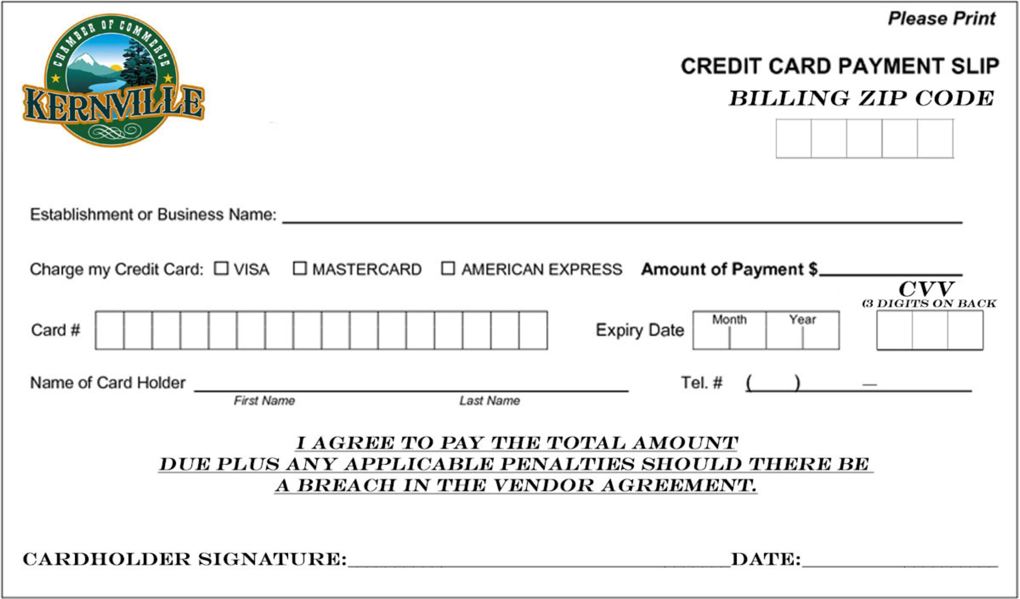

Cancellation & Refund Policy

EVENT CANCELLATION BY HOST
The Kernville Chamber of Commerce reserves the right to cancel an event due to circumstances that would make the event non-viable.

If the Kernville Chamber of Commerce cancels an event, registrants will be offered a full refund.

If an event is postponed, registrants will have the option of receiving a full refund or transferring registration to the same event at the future date.

The event registration is non-transferable.

EVENT REGISTRATION CANCELLATION BY PARTICIPANT
The deadline to receive a refund for cancellation is as follows:
- 30 days prior to event - 100%
- 29 - 15 days prior to event - 50%
- Within 14 days prior to the event - 0%
Cancellations will be accepted via phone or email but must be received by the stated deadline.

All refund requests must be made by the attendee or credit card holder.

Refund requests must include the name of the attendee.

Refunds will be credited back to the original credit card used for payment.

The event registration is non-transferable.

DEPOSIT REFUND INFORMATION:

Refund will be returned at end of event if your space was left clean & you did not leave event early.
If you paid by Credit Card, your refund would go back to the credit card you used within 7 – 10 days.
Payment made by Money Order & Cashier Check; refunds will be distributed by check on the last day of event at the Info Booth.

Cancellation & Refund Policy: I have read and understand all the above and agree to this policy.

Print Name Signature and Title Date

